Reviewer 3
For all responses, new text is underlined.
1. Abstract, Methods and Results: The definition of the Likert Scale is not defined, so it is hard to follow the qualitative results presented.
Thank you for the comment, we have included a statement regarding the scoring, and provided a table showing the exact breakdown of the Likert scoring used in this work.
The predicted CRLM and ablation contours were scored independently based on a Likert quality scale of 1-5. A breakdown of these scores can be found in Supplementary Table 1. A score of 4 is defined as requiring minor changes on less than four slices, or changes that would require less than 10 seconds to fix.
2. Introduction: The challenge of segmenting secondary liver disease in CECT compared to manuscripts focusing on primary liver disease should be explained in more detail and why novel methods considered in this manuscript can help with secondary liver disease such as CRLM should be stated clearly.
Need help here
3. Methods page 2:
a. Why were cases with hyper-enhancing metastases, large cystic lesion and atypical enhancement patterns removed? Does this mean the models will not work for certain patients and those patients need to be identified manually?
The authors created this model specifically for use of treating patients with colorectal liver metastasis, our work with interventional radiologists was to identify a cohort of patients most representative of the population which receives ablation therapy. We evaluated the models predictive abilities on a variety of patients seen in our clinic, and on two publicly available datasets, with positive results, but it would be overstating to say the model will always work on all patients.
b. What kind of image acquisition parameters were critical? – why were patients excluded based on this criterion.
Some of the publicly available data did not have slice thickness or pixel-spacing defined. These are necessary parameters for any resampling during the training process. Per Table 1, the slice thickness varied from 0.7-5mm, so presuming the values was not feasible.
c. Are the LiTS and 3D-IRCADb01 datasets distributed with predefined training and test splits? This is not clear.
The LiTS challenge has a designated test split, where predictions must be submitted online, and the ground truth is never known. The 3D-IRCADb01 was never used for training, only for evaluation.
d. What kind of image annotation was present in these datasets? Were they used as ground truth as is or reviewed?
Image annotation was provided in the form of a binary mask. These were used as a ground truth.
e. In the abstract, local liver dataset of 18 patients was mentioned, but no description of this is provided in the methods.
Description of the 18 patients is provided in the ‘Qualitative Evaluation’ section
We retrospectively identified 18 patients, who had previously undergone targeted thermal ablation therapy at our institution under an Institutional Review Board-approved study (IRB: 2019-0213); these patients had 24 CRLM sites and 19 ablation sites. The predicted CRLM and ablation contours were scored independently based on a Likert quality scale of 1-5. A breakdown of these scores can be found in Supplementary Table 1. A score of 4 is defined as requiring minor changes on less than four slices, or changes that would require less than 10 seconds to fix.
f. Are there no demographic information for the datasets used? What were their disease indications? How will you generalize this study to other populations/datasets without this information.
4. Methods, Image intensity manipulation:
a. Mean and standard deviation of what? Hounsfield values?
Thank you, we have specified that this is Hounsfield units
b. So you applied patient specific normalization because you had the liver masks – but how will this translate to new datasets that do not have liver mask?
This model requires segmentations of the liver to be present. There are already several commercially available software packages for segmenting normal liver.
5. Training Image “Slabs”:
a. What classes are you talking about here? How many classes were there? Who determined the classes? No definition of the ground truth or target variables is provided before this paragraph.
We apologize for this not being more readily apparent. We have expanded the previous section as follows
To ensure reproducibility by other institutions, we used data provided by the publicly available LiTS challenge¹¹. LiTS consists of CECT scans from 131 patients with primary and secondary liver disease. Ground truth segmentations of the liver and disease were provided, the goal of our model is to similarly segment the disease. Each image was reviewed by XXX to remove the data showing hyper-enhancing metastases, or lacking image acquisition parameters. 92 patients remained.
b. What kind of loss functions were used for initial training?
Initial training was attempted using the same loss function as presented further on. This section was provided to help express that we investigated training on the entire liver.
c. Slabs are provided without context. What was the median size of the datasets after resampling?
d. Figure 1 does not have any captions or the corresponding groundtruth/mask files.
Visualization of the disease on the liver was originally felt to be difficult, we have updated the image and caption of the figure to help illustrate.
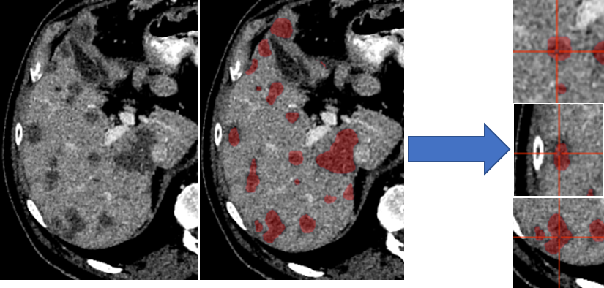
Figure 1: Liver distributed into individual cubes of 32x120x120 (LiTs volume 108). Ground truth of disease was provided by LiTs challenge. The validation and test set were not broken into cubes; our architectures accepted variable input sizes, with the entire liver being passed at once for evaluation and testing.
e. How the slab size determined is also not clear.
Slab size was chosen arbitrarily as a balance between providing a cross section of the liver, and reducing memory requirements for training.
To account for disparities in class representation, where smaller structures (CRLM) are inherently “worth less” than large structures (normal liver), we distributed our training into unique “slabs”. Each independent disease site was divided into “slabs” of 32x120x120 voxels. This size was selected arbitrarily as a balance of encompassing a large section of liver while reducing memory requirements. This ensures a representation of both disease and normal liver in each training step.
f. What do you mean by after extraction 572 unique samples remained? Are you not training using all the slabs for a patient at the same time?
We apologize that this was not more clear. All of the slabs for a patient are available during the training process. Some patients will have more slabs than others, based on the amount of disease present.

I stopped reviewing after this point as I am not able to follow the training process due to insufficient details.
We apologize for the insufficiency of necessary details. We believe that some of your questions referenced above are answered further in the document, and feel confident that we can provide more information regarding training as needed.

Reviewer 4
The use of Convolutional Neural Networks needs a larger dataset to get accurate results. If the dataset is limited, a data augmentation stage will be mandatory.
Thank you for the response. The authors did investigate providing augmentations in the form of flipping and mirroring the provided slabs during training. A statement on this has been added to the document.
For training each model, a variation in the cyclical learning rate¹⁸ was used (GitHub link: anonymized for review), with linear increase and decrease between min and max. Optimal learning rates vary based on each architecture parameter, with the minimum and maximum learning rates identified using an in-house function (Github link: anonymized for review), Supplementary Figure 1. Augmentations of the training was provided in the form of flipping and mirroring the input data.
The number of keywords is more than expected.
The keywords can be reduced to what the reviewers think are most pertinent.
Qualitative assessment is a strong point in the paper, however, results in Table 5 need statistical evaluation to check whether there is a signifcant difference or not.
Need to do this
It is recommended for quantitative evaluation to get the confusion matrix
Need to do this
Avoid extensive use of words like "we", "our", "us", ......
We greatly appreciate this comment, a significant number of the uses of ‘we’, and ‘our’ have been changed to a more neutral tone.
"The mean sensitivity was only 7% in disease sites <10 mm in diameter" while other studies had given higher sensitivity. Please add a detailed interpretation and suggest how to improve the suggested methodology to get higher values of sensitivity.

